- Install git. ?
Installation of Git on Amazon Linux EC2
- First, connect to the Amazon Linux EC2 instance using SSH.
- Update the system packages to ensure the server has the latest available updates.
- Install Git using the Amazon Linux package manager, yum.
- After installation, verify that Git has been installed successfully by checking its version.
- Configure the Git username and email address using the Git configuration commands.
- Verify the Git configuration to make sure the username and email address have been saved correctly.
- Git is now successfully installed and configured on the Amazon Linux EC2 server and is ready to use for version control and managing projects.
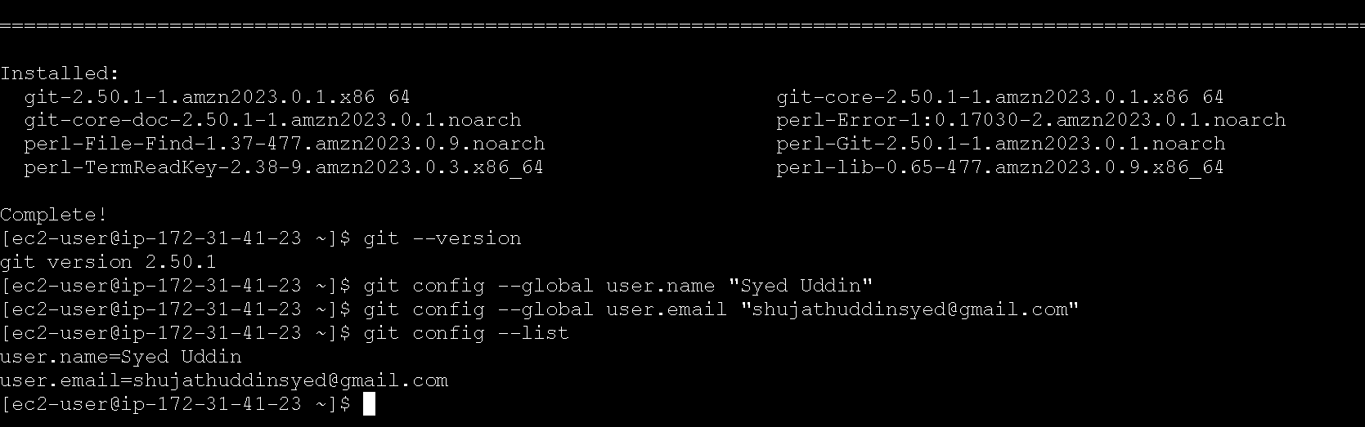

- Create a repo in github with README.md and .ignore file.
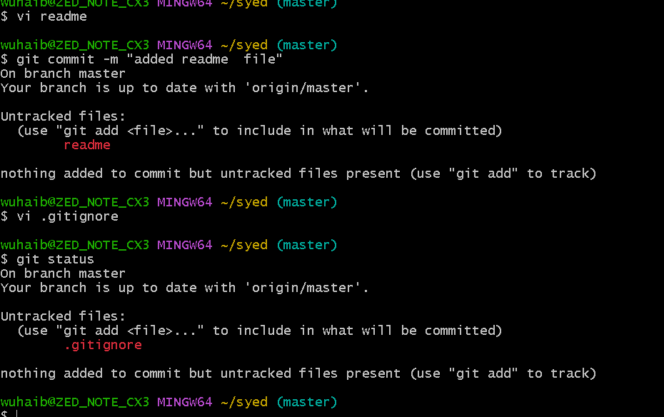

- Clone the created repo to local.
Clone GitHub Repository to Local — Steps
- Open Git Bash on your Windows computer.
- Go to the folder where you want to save the repository.
- Copy the SSH URL of your GitHub repository.
- Use the Git Clone option to download the repository.
- Enter the cloned repository folder.
- Check the repository files.
- Verify that the repository is connected to GitHub.
- The repository is now successfully available on your local computer.

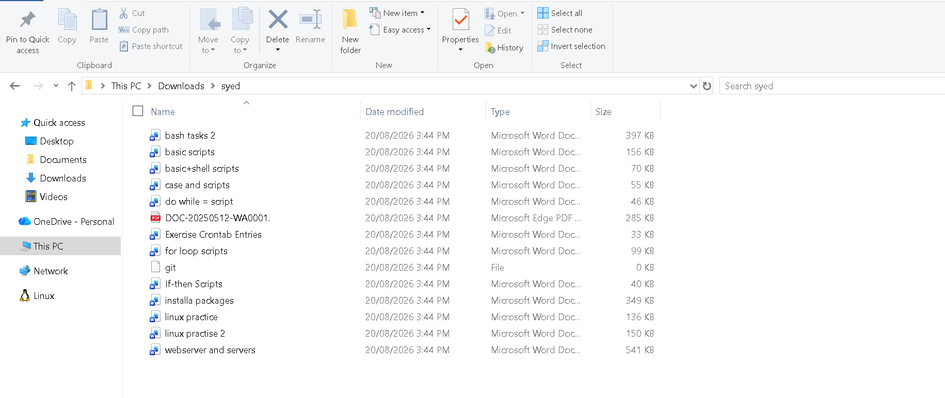

- Create two files in local repo.
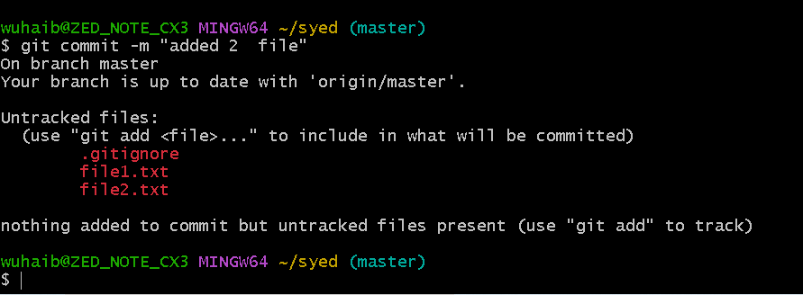

- Commit two files and push to central Repository.
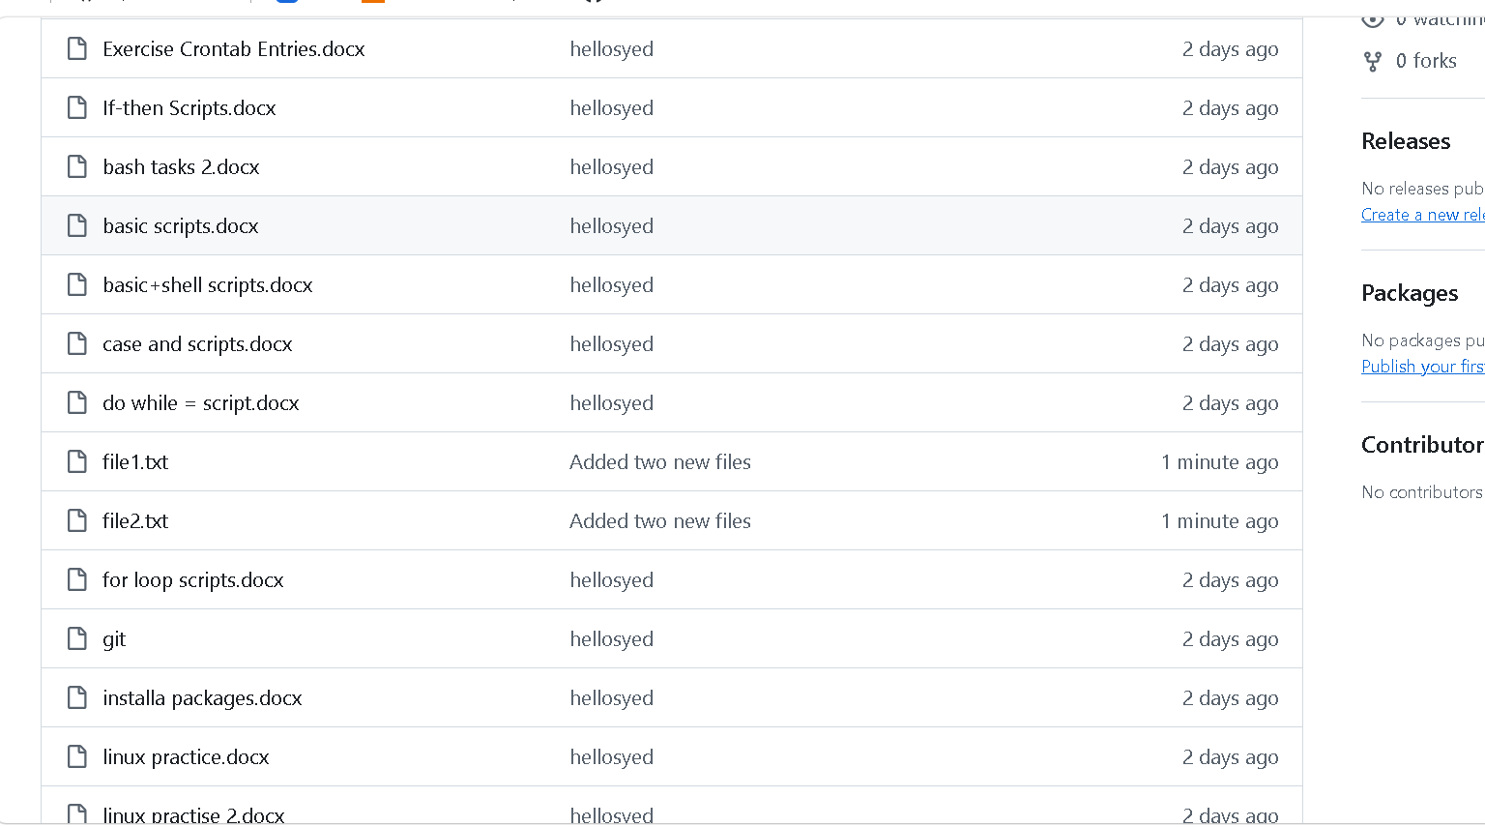

- Create a branch in local and create a sample file and push to central.
Create a Local Branch and Push to GitHub — Steps
- Open Git Bash.
- Go to your local syed repository.
- Check the current branch.
- Create a new branch, for example development.
- Switch to the new branch.
- Create a sample file inside the repository.
- Check that the sample file was created.
- Add the sample file to Git.
- Commit the sample file with a suitable commit message.
- Push the new branch to the GitHub repository.
- Open GitHub and refresh the repository.
- Check the Branches section and verify that the new development branch is available.
- Open the development branch and verify that the sample file is present.

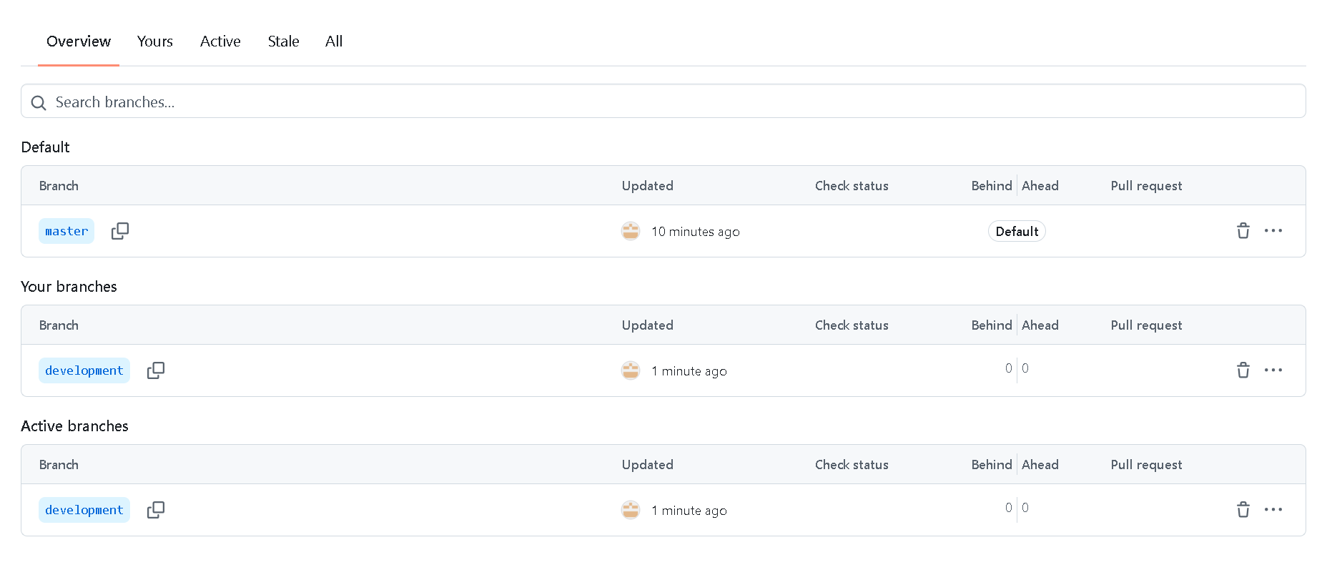

- Create a branch in github and clone that to local.
Create a Branch in GitHub and Clone It to Local — Steps
- Open your GitHub repository syed.
- Click the Branch dropdown.
- Enter a new branch name, for example development.
- Select Create branch: development.
- The new branch is now created in GitHub.
- Open Git Bash on your computer.
- Go to the location where you want to keep the repository.
- Clone the GitHub repository using its SSH URL.
- Enter the cloned repository folder.
- Fetch the latest branches from GitHub.
- Switch to the development branch.
- Verify the current branch.
- Confirm that you are now working on the development branch locally.

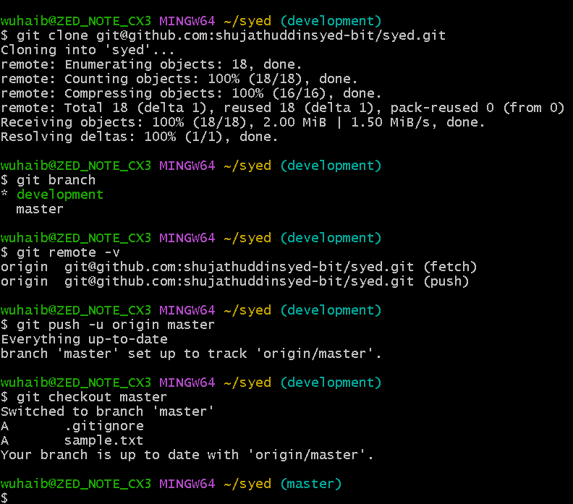

- Merge the created branch with master in git local.?
Merge the Created Branch with Master — Steps
- Open Git Bash.
- Go to your local syed repository.
- Check the available branches.
- Switch from the created branch to the master branch.
- Make sure you are currently on the master branch.
- Merge the created branch into the master branch.
- Check the Git status to confirm the merge was successful.
- Verify that the files from the created branch are now available in master.
- The created branch is now successfully merged with master locally.

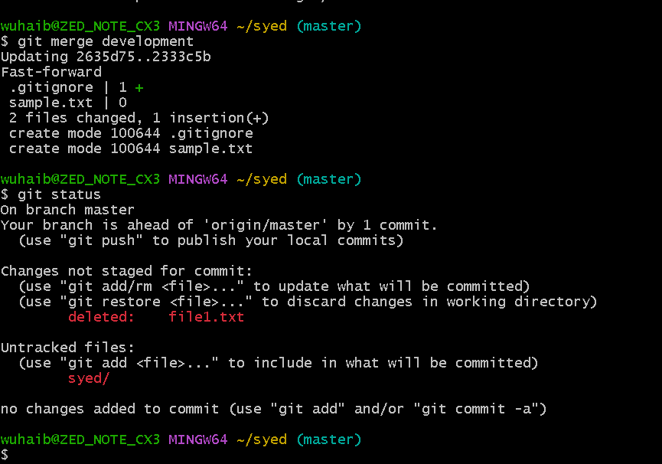

- Merge the created branch with master in github by sending a pull request.
Practical Example (End-to-End)
Assume:
- Repository name: myproject
- New branch name: feature-login
- Main branch: master
1. Open Git Bash and go to the project
Bash
cd myproject
2. Switch to master and update it
Bash
git checkout master
git pull origin master
3. Create a new branch
Bash
git checkout -b feature-login
Output:
Switched to a new branch 'feature-login'
4. Create a sample file
Bash
echo "Login page added" > login.txt
5. Add and commit the file
Bash
git add login.txt
git commit -m "Added login page file"
6. Push the branch to GitHub
Bash
git push origin feature-login
Output:
* [new branch] feature-login -> feature-login
Create Pull Request on GitHub
- Open your repository on GitHub.
- Click Compare & pull request (or Pull requests → New pull request).
- Choose:
  - Base: master
  - Compare: feature-login
- Click Create pull request.
- Click Merge pull request.
- Click Confirm merge.
Your feature-login branch is now merged into master.

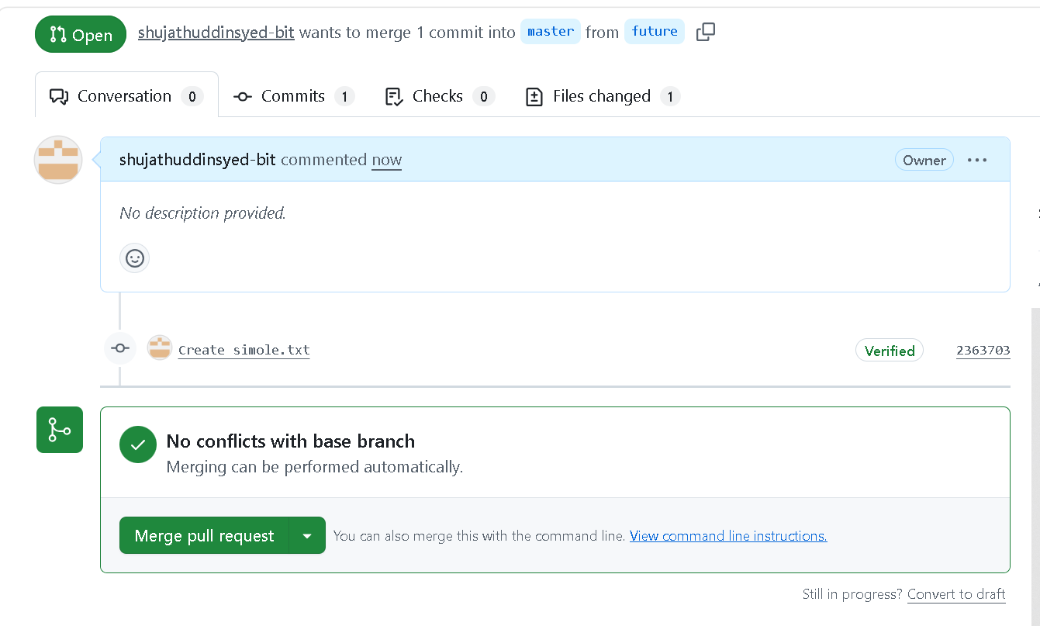

- Create a file in local and send that to branch in github.?
Procedure
- Open Git Bash and navigate to the local project folder.
- Switch to the required branch using git checkout feature1.
- Create a new file (for example, file1.txt) and save the content.
- Add the file to the staging area using git add file1.txt.
- Commit the file with a message using git commit -m "Added file1.txt".
- Push the committed changes to the GitHub branch using git push origin feature1.
- Open GitHub and verify that the file is present in the feature1 branch.

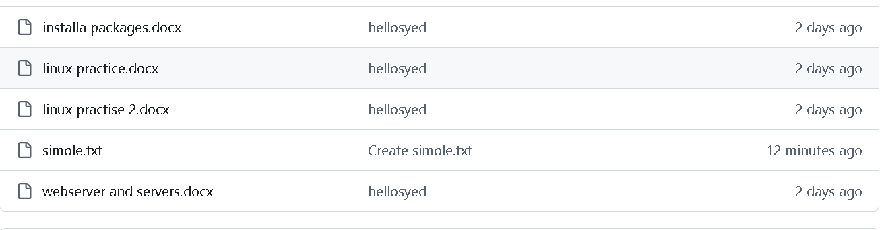

- Clone only a branch from github to local.
Procedure
- Open Git Bash.
- Copy the GitHub repository URL.
- Use the git clone command with the --branch and --single-branch options.
- Wait for the cloning process to complete.
- Open the cloned folder and verify the current branch.
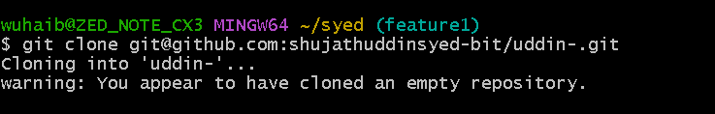

- Create a file with all passwords and make that untrackable with git.
Procedure
- Open Git Bash and go to your project folder.
- Create a password file named passwords.txt.
- Create or open the .gitignore file.
- Add passwords.txt to .gitignore.
- Save the files and verify that Git does not track the password file.
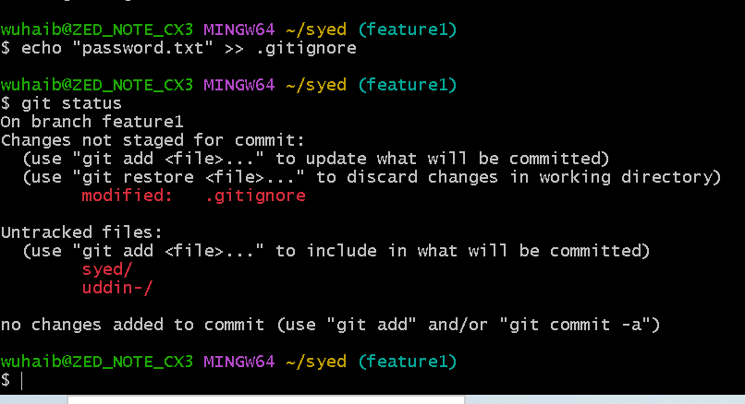
- Make a commit and make that commit reset without savings changes.
Aim
To make a commit and reset it without saving the changes.
Procedure
- Create or modify a file.
- Add the file to the staging area.
- Commit the changes.
- Reset the last commit and discard all changes.

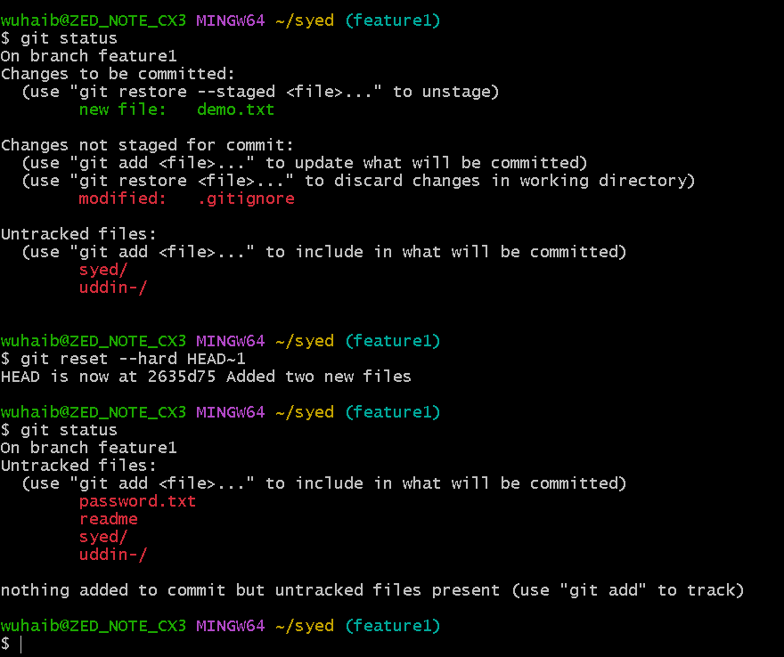
- Revert a commited commit to the older version.
Procedure
- Open Git Bash.
- Navigate to the local Git repository.
- Display the commit history using git log --oneline.
- Identify the commit to be reverted.
- Execute the git revert command for the selected commit.
- Save the default commit message if prompted.
- Verify the revert by checking the commit history again.

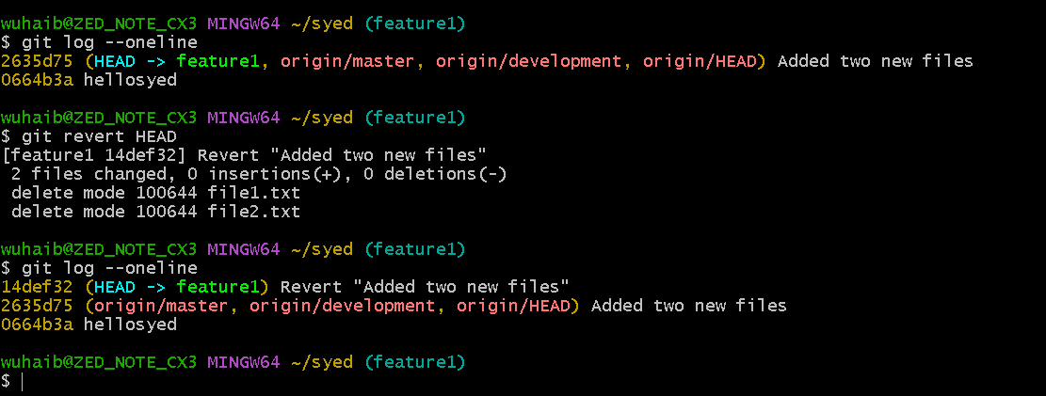

- Push a file to stash without savings the changes and work on another file.
Procedure
- Open Git Bash and navigate to the repository.
- Modify or create file1.txt.
- Check the changes using git status.
- Save the changes to the stash using git stash.
- Create or edit another file (file2.txt).
- Continue working on the new file.

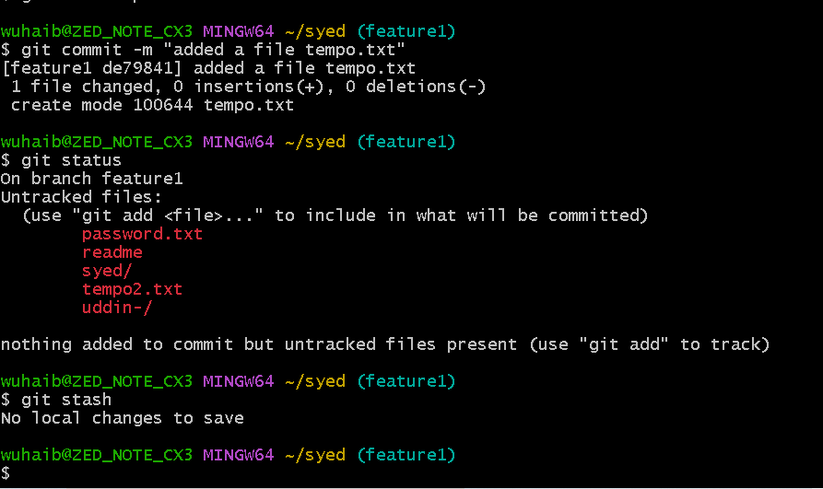
- Undo the stash file and start working on that again.

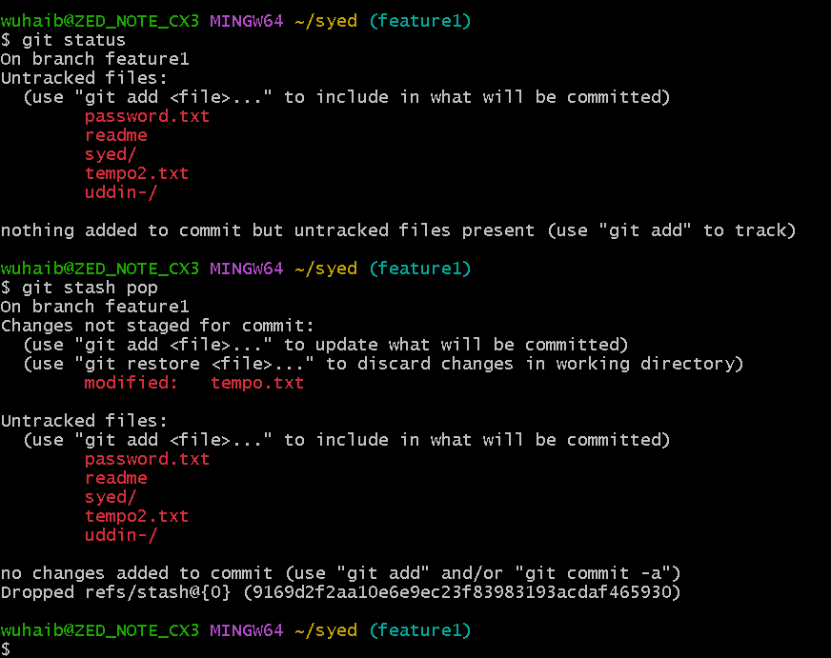

- Generate a ssh-keygen and configure into github.
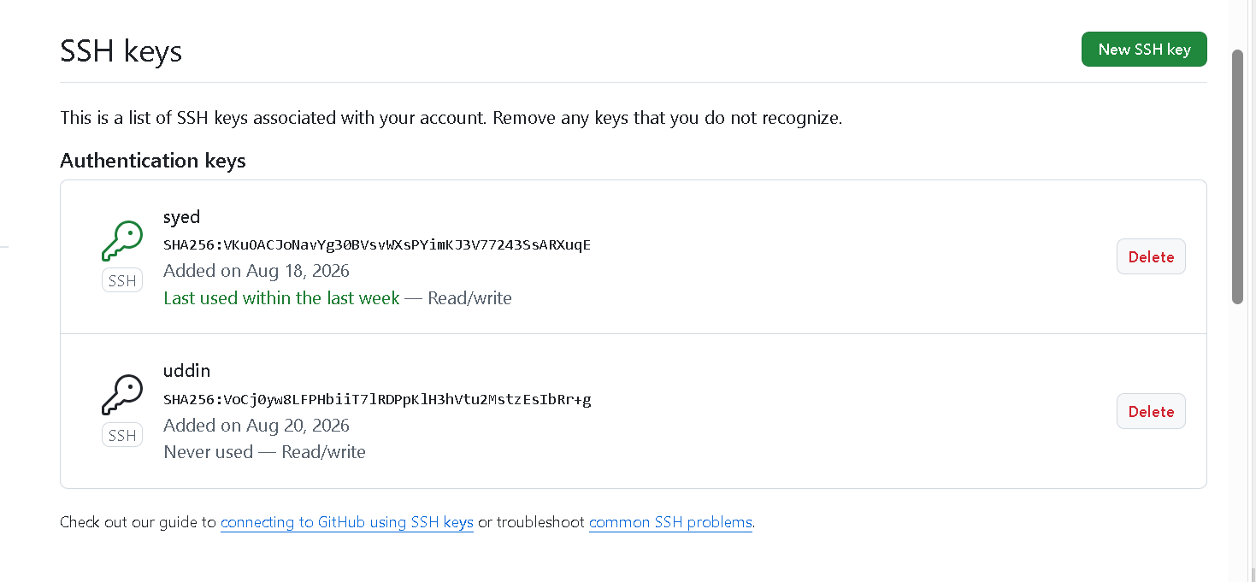

- Configure webhooks to github.
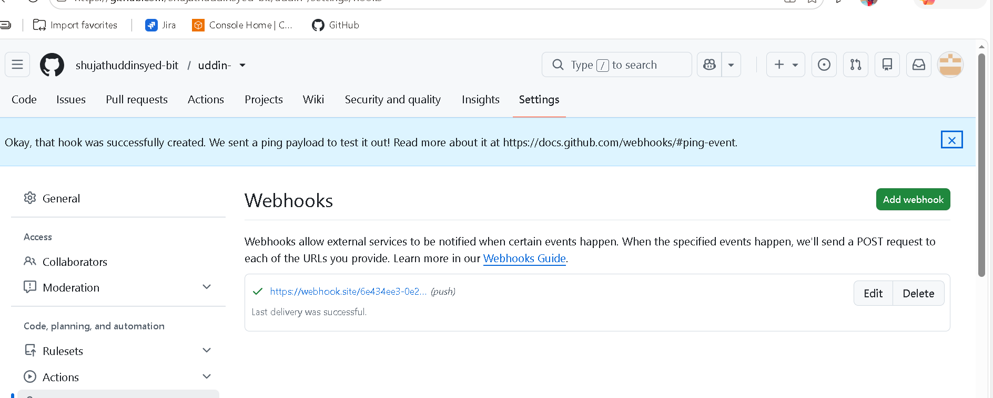

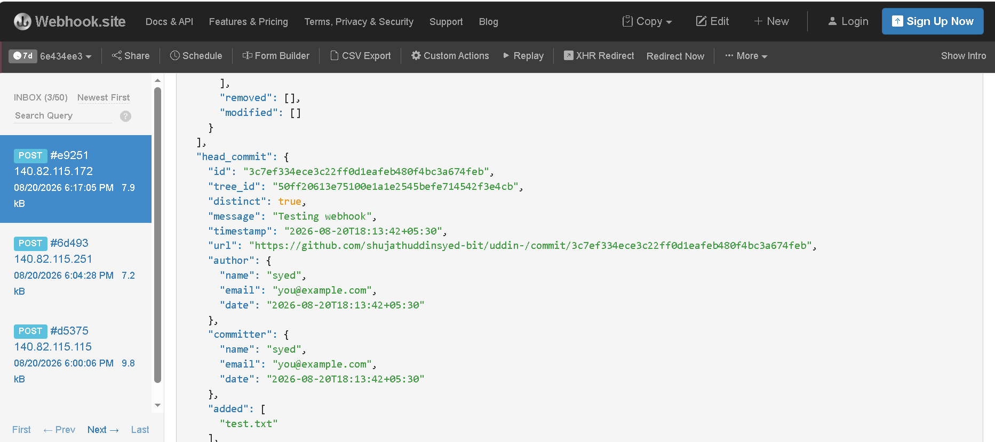

- Basic understanding of .git file.
Ans The .git folder is the hidden directory that Git creates when you run git init. It stores the complete version history and configuration of your repository.
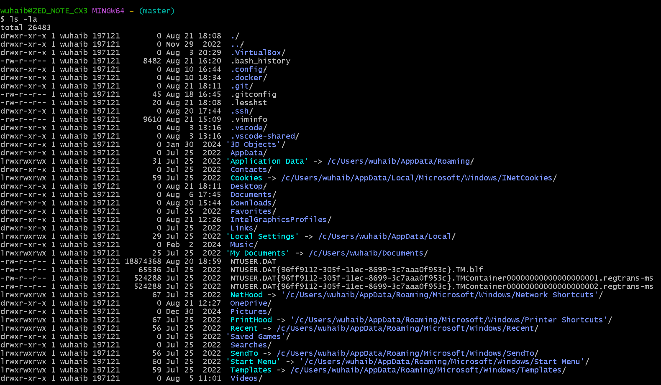

- Check all the logs of git.

Procedure
- Open Git Bash.
- Navigate to the local Git repository.
- Use the Git log command to display all commits

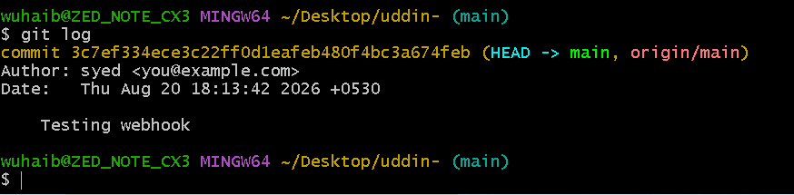
- Rename the commit message.
Aim
To rename (change) the most recent Git commit message.
Procedure
- Open Git Bash.
- Navigate to your Git repository.
- Change the last commit message.
- Verify the updated commit message.
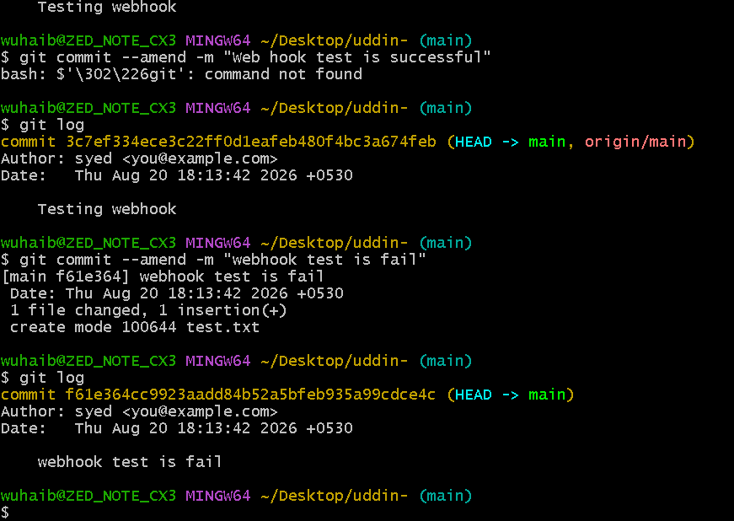

- Merge multiple commits into single commit.
Procedure
- Open Git Bash.
- Navigate to your Git repository.
- View the recent commits.
- Start interactive rebase.
- Squash the commits into one.
- Save and verify the new commit history.
